**Project on Face Recognition**

END TERM REPORT

*by*

|  |  |  |  |
| --- | --- | --- | --- |
| S.N. | NAME | SECTION | ROLL NO. |
| 1. | Bishab Pokharel | K18SJ | 33 |
| 2. | Ganesh KC | K18SJ | 32 |
| 3. | Yunish Pokharel | K18SJ | 36 |
| 4. | Rohan Dhungel | K18SJ | 60 |



**Department of Intelligent Systems**

**School of Computer Science Engineering**

**Lovely Professional University, Jalandhar**

April,2020

**Student Declaration**

This is to declare that this report has been written by me/us. No part of the report is copied from other sources. All information included from other sources have been duly acknowledged. I/We aver that if any part of the report is found to be copied, I/we are shall take full responsibility for it.

Bishab Pokharel,Roll No:33

Ganesh KC, Roll No:32

Yunish Pokharel,Roll No:36

Rohan Dhungel, Roll No:60

Phagwara

4 April,2020

**TABLE OF CONTENTS**

**TITLE Page no.**

1. **Background and Objectives of the Project………………………… 05-06**

**1.1. Objectives before development………………………………..... 05**

* 1. **Motivation of the Project………………………………………... 05**
  2. **Goal of the Project……………………………………………....... 06**
  3. **Outcome of the Project………………………………………….. 06**

1. **2.Description of the Projects………………………………………… 06-08**

**2.1. Grassroot Description of Platform……………………………... 06**

**2.2. Modular Description…………………………………………….. 06-07**

**2.3. Modules………………………………………………………….. 07**

**2.4. Work Division…………………………………………………… 07-08**

**3. Implementation of the Project……………………………………… 08-10**

**4.Technology and Framework………………………………………… 11**

**5.SWOT Analysis of the Project……………………………………….. 08-10**

**5.1. Strengths of the project………………………………………… 08**

**5.2. Weaknesses of the project……………………………………… 09**

**5.3. Opportunities from the project……………………………… ….. 09**

**5.4. Threats to the project………………………………………… 09-10**

Bonafide Certificate

Certified that this project report “PROJECT ON FACE RECOGNITION” is the bonafide work of Bishab Pokharel, Ganesh KC, Yunish Pokharel and Rohan Dhungel who carried out the project work under my supervision.

Signature of supervisor

Name of Supervisor

Academic Designation

ID of Supervisor Department of Supervisor

1. **Background and objectives of the project:**

A responsive and a well working “Face Recognition Project” to be made using python framework was presented as our final project. This game is developed with the use of main two libraries of python esp. OpenCV and Tkinter (optional, and for giving it the graphical touch). This project’s interface is based on a Graphical User Interface (GUI) basis and a user can make use of device camera to work upon the facial recognition performance.

Though the works of development are carried out using python language, we have, at our best, tried to include most of the skills and techniques we were taught while pursuing INT404 as Artificial Intelligence.

This project model is made dynamic and interactive that allows the user to run the project with lowest possible errors and bugs. Most of them are solved and fixed while in the development phase.

* 1. **The major objectives before developing the project were:**
* To develop a full-fledged project with the use of a programming language.
* To carry out the application development work in a team allocating the specified works on module bases.
* To solve the problems that could possibly arise while developing an application in a group.
* To learn through the phase of development, about how to integrate the individual modules and how the modules collectively work to make it an interactive software ready to install to the users.
  1. **Motivation:**

The ideas and skills were duly observed and implemented from the Artificial Intelligence (INT404) and python programming classes. The new and interesting platform of OpenCV Library with loads of methods was very helpful for developing the project. The motivation for the project, therefore, is all of its interesting and user-friendly libraries and ideas via INT404.

* 1. **Goal of the project:**

The major goal of the project is to implement the coding and developing skills taught in Artificial Intelligence and to give the ideas a complete shape through a well working project assigned on the first hand.

* 1. **Outcome of the project:**

The outcome of the project is a “Face Recognition Project” that can be operated like a normal software developed via python and its library namely OpenCV. The phases of its development are well described in this report and the working project is submitted for the inspection.

1. **Description of the project:**

The project development was started with the preparation of synopsis, via which we arranged the required time, effort and the division of works among members in a group.

Github link for the project is: <https://github.com/bishab/PROJECT_FACE_RECOGNITION.git>

* 1. **Grassroot Description of platform:**

This application is developed using “OpenCV”, a very useful library in python for Image Processing and Facial Recognition. Besides, we also used the other library i.e. Tkinter in its development, mainly for buttons and other user-friendly elements to put in it. So, this is somehow a GUI based application that can be used using buttons and cursors in a graphical interface.

* 1. **Modular Description:**

Firstly, the individual modules were prepared that were allocated to each of us. After completing the development of individual modules, the process of giving a complete shape to the project was done collectively.

The major features of the project are listed below:

* Graphics
* Interactive Buttons for displaying messages and notifications
* Libraries identification and analysis of their usage
* Functions related to the interaction of camera and photo with their operation.
* Functions related to reading of image (IMAGE PROCESSING).
* Object Oriented Concept(OOP) usage for classifying and simplyfying the code.
  1. **Modules:**

On the basis of above functions, we have divided the whole project into a number of twelve different modules as described below:

1. Module-1(Graphics): In this module the front-end features(buttons) required for the project are induced. The user will happen to run it before getting inside the face recognition.
2. Module-2(Message displaying): This module consists of four functions which are used to display the messages for different conditions arising while operating the software.
3. Module-3(Camera features): This module deals with the opening nad closure of camera along with the execution of the code.
4. Module-4(Libraries): This module consists of the libraries and its methods via which we analyse and run the camera or given picture for the sound performance.
5. Module-5(Error Control and handling): This module consists of the backend analysis and solving of the errors that were obtained while running the project. So this is basically an error detection task assigned to one of our members.
6. Module-10(OOP): This module consists of classification and arrangement of the raw code into more detailed and easy format using OOP concept.

The above listed modules were allocated to each of us that were to be developed oneselves on the first hand. Later, the adjoining of all those modules was carried out in a group.

* 1. **Work Division:**

The division of work is on the basis of Six Detailed Modules. The four members of our group were allocated the following modules:

1. Bishab
   * + Tasks related to OOP and camera features as described In module 6 and 3.
2. Ganesh:
   * + Task related to OpenCV libraries and basic button graphics described in module 1 and 4.
3. Yunish:
   * + Error control and handling after the overall writing of the code as described in module 5.
4. Rohan:
   * + Creation of messages and display of those messages on various circumstances when the environment is not usable or likewise.
5. **Implementation of the Project:** The implementation of our project is described herewith with the help of the screenshots of the running project.
6. GUI and user-friendly appearance:

Here, the user while runs the code, gets to have two options for choosing the formats. The options are duly arranged with buttons from tkinter.

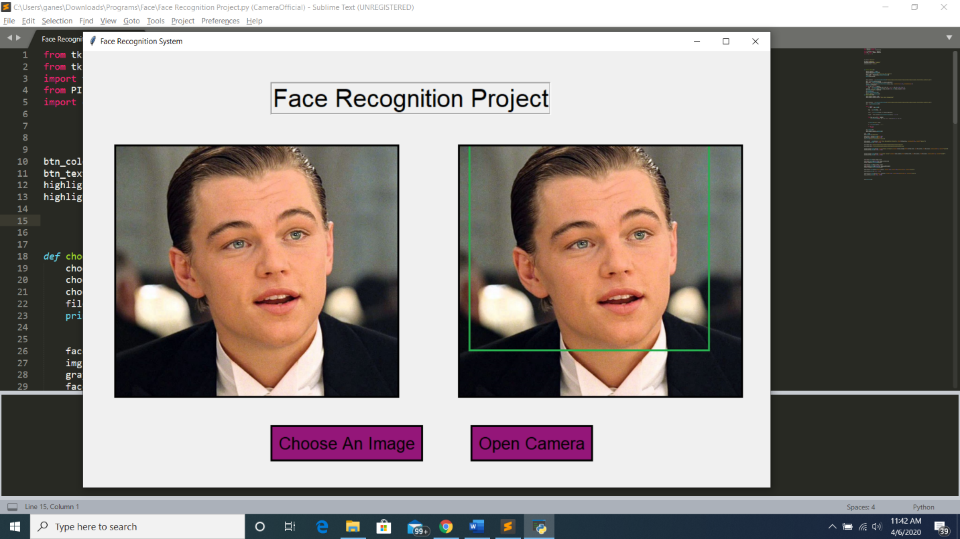

1. Response to the local host for uploading picture:

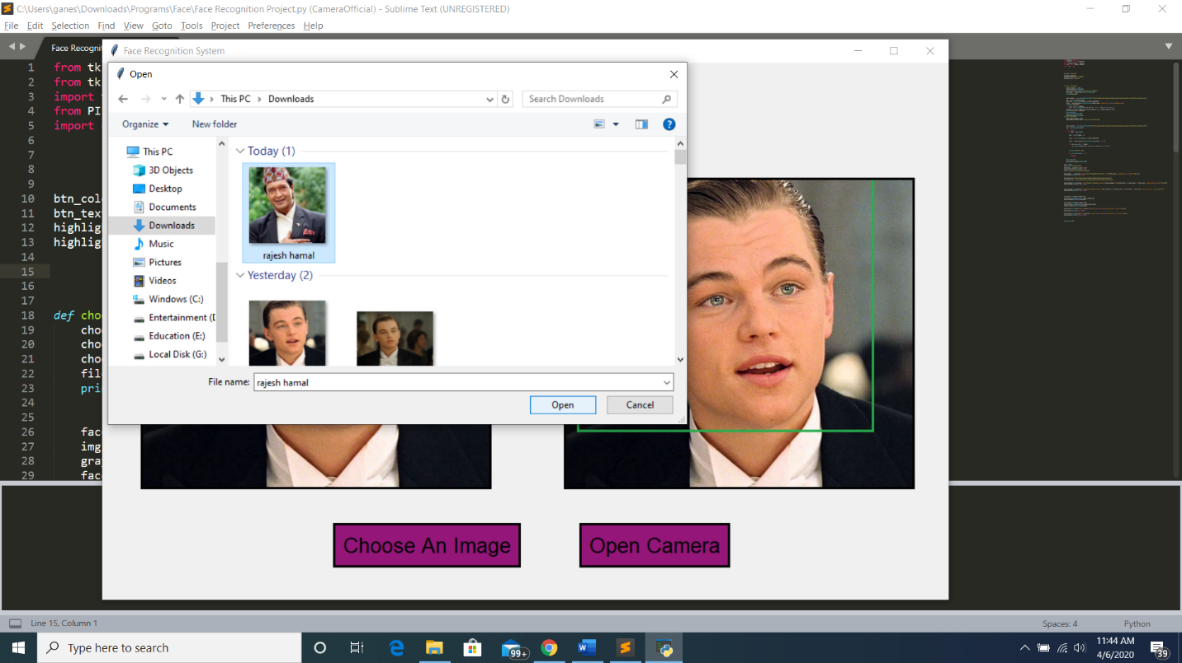This is one of the challenging part to receive images for localhost yet solved without any errors. Here the user gets to select the photo from his/her file menu.

1. Face Recognition:

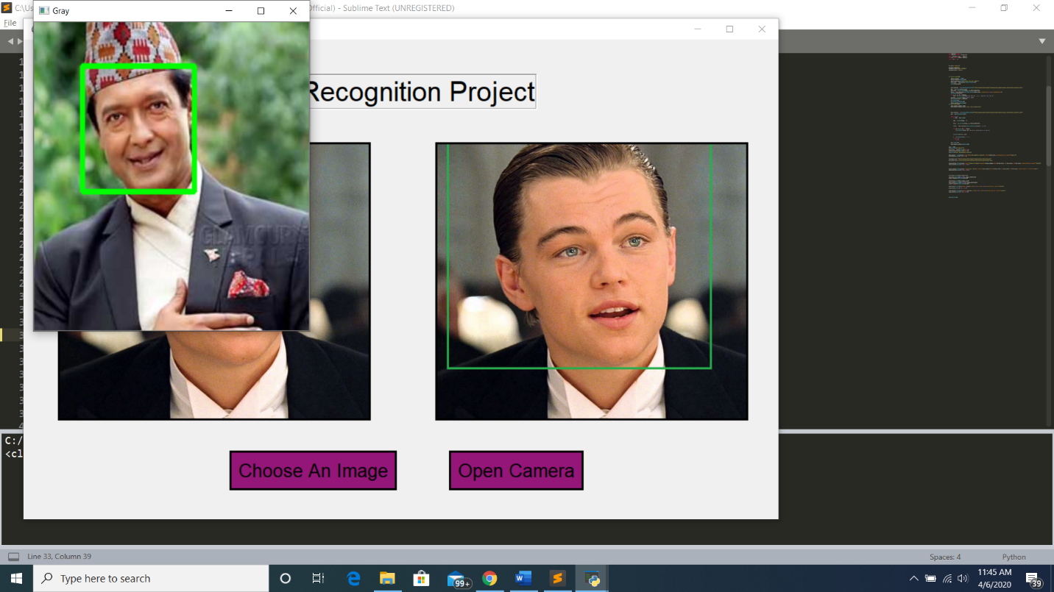In this part of the project, the uploaded image will be analysed, read and finally the face part will be recognized by the software.

1. Recognition via Camera:

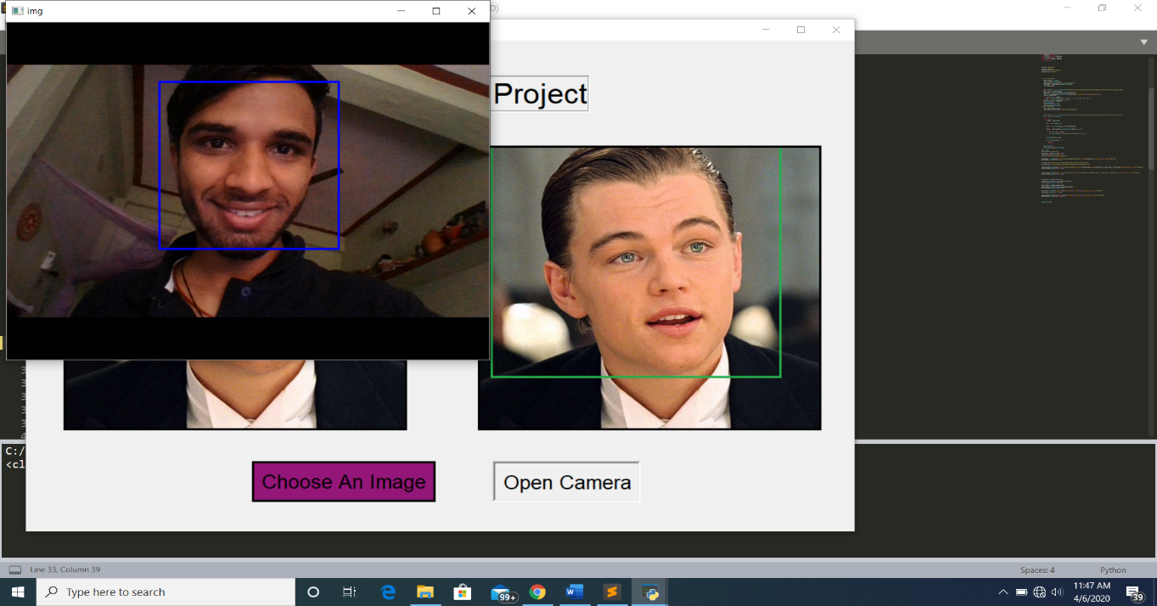This part will let our user to have the camera opened and simultaneously the face of the person will be recognized by the software.

1. **Technology and Frameworks:**

As stated earlier, this complete project is based on ideas learned in Artificial Intelligence, implementation carried out in Python OpenCV and its libraries. Most of its modules are made with the help of Tkinter library and the rest others are made with other functionalities of OOPs learned in all other programming language.

1. **SWOT Analysis of The Project:**

The SWOT analysis of the project includes Strengths, Weaknesses, Opportunities and Threats in the project. We have tried to analyze the all of them on the basis of our project which are discussed in details below:

* 1. **Strengths of the project:**

This application is strongly capable to work well under any python interpreter where given libraries are installed(pre-condition) and thus, with no found possible bugs and errors. This makes the project a strong and a capable enough to perform its tasks.

* 1. **Weaknesses:**

Though the application is in good working condition, yet it needs all of its composition files in a single place. If, in an IDLE, we are trying to use it, it needs all of the files in a certain destined folder and paths. Other than this, the project hardly has any weaknesses.

Besides the working of the project, the other weaknesses experienced while preparing the project were during the combining phase of individual modules that contained different variable declarations as the modules were prepared on individual basis.

* 1. **Opportunities:**

This project helped to gain loads of opportunities while in its preparation phase.

* It helped us gain ideas while developing project module wise
* The possible errors like declaring the variables via different names and its solutions of declaring global variables were taught through the errors.
* This project helped us to gain ideas about how the libraries are wisely used while developing a complete project to the third person.
* The preparation of synopsis and reports taught us to implement the project on a hard copy on the first hand for various future references.
  1. **Threats to the project:**

Though the precautions were applied while preparing the report, it might still have number of threats when the application is exposed to the outer world.

* The software is not strong enough to hold the testing as those are not entertained in the project.
* The camera issues if present with the hardware might turn out to be an issue in the working condition of the project. Other than this, there are hardly any problems and threats in our code.
* The project might have problems while parsing the related documents to the operating systems, which might occur due to the un-supportability of the systems, maybe due to the absence of packages remained uninstalled in given framework.
* Once a file is deleted, it brings out number of errors to the application. So, the consistency of the application might be a possible threat for it.

These points can be considered to be the supporting facts and figures about Strengths, Weaknesses, Opportunities and Threats when the project is exposed to the outer world.